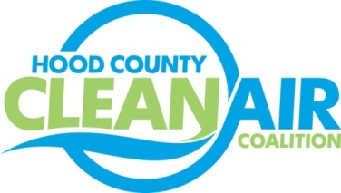
Meeting: Thursday, July 6, 2017
Neely House
304 East Rucker Street, Granbury, Texas 76048
8:30-10:00 a.m.

Agenda

- Call Meeting to Order
- EPA Updates – Randy Pitre, EPA
- Local Updates – Michelle McKenzie
  - Review of June Meeting Summary
  - Reports
    - June Ozone Update
    - Texas Regional Air Quality Planning Group Meeting
    - SolSmart Webinar
  - Annual Minutes
  - Review of Projects
    - Monthly Budget Review for May
    - Status of Projects FY 16/17
- Regional Updates – Chris Klaus, NCTCOG
  - Regional Air Quality Update
  - EPA Press Release for Extension to Deadline for Nonattainment Designations
  - First Responder Alternative Fuel Vehicle Safety Training August 2-3
  - DFW Clean Cities Meeting July 11 – Lunch provided
- Loss of Rider 7 Funding
- Other Discussion
- Adjourn

